**The-Maskateer**

<http://demo-webdesignservices.com/The-Maskateers/>  
  
Backend Credentials are,  
<http://demo-webdesignservices.com/The-Maskateers/admin>  
  
User : [admin@themaskateers.com](mailto:admin@themaskateers.com)  
Password : !$ecret!  
  
update 1 (10 working days - 2 Sep):  
- Admin Setup  // Done  
- HTML / Framework Setup // Done  
- Logo Management // Done  
- Banners Management // Done  
- CMS Management // Done  
- Contact / Social Info Management // Done  
- Inquiries Management // Done   
- Category Management // Done (Not found)  
- Products Management // Done  
- Partners Management // Done  
- Newsletter Management (store emails) // Done   
- Gallery Management // Done  
- FAQs Management // Done  
- VOLUNTEER Management // Done (Not found)  
- News Management // Done  
- Reviews Management // Done

update 2 (05 working days - 09 Sep):  
- Product Listing  
- Product Detail  
- Add to Cart  
- Checkout Steps  
- Registration module  
- Login / Logout  
- Forgot Password // done

- My Account Dashboard  
- Account Setting  
- Reset Password  
- Order Management  
- Order History (account area)  
- Invoices (Order invoice not receiving in user’s email)  
- Merchant integration (please provide merchant) (Merchant missing)

1. This section is static and link learn more button to respective page.  
   QA: Not done
2. Comment: this section is not needed to be dynamic if client require this we will work on it further

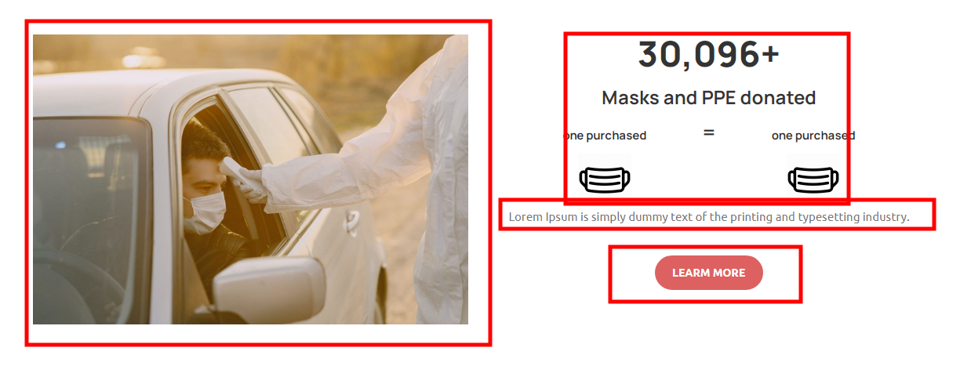

1. Set image position  
   QA: Not done @html  
     
   
2. When we subscribe for newsletter change notification text to relevant text  
   QA: Not done  
     
   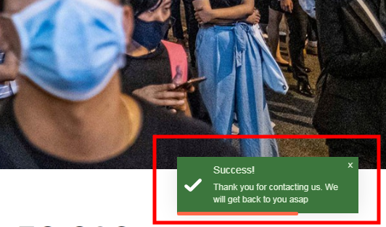
3. Link is wrong kindly appropriate link  
   QA: Not done COMMENT: Only appropriate links are working i.e Maze Stephan, Sushant Thomas and Laurie McElwee rest team members links are not provided us.  
   <http://demo-webdesignservices.com/The-Maskateers/about-us>

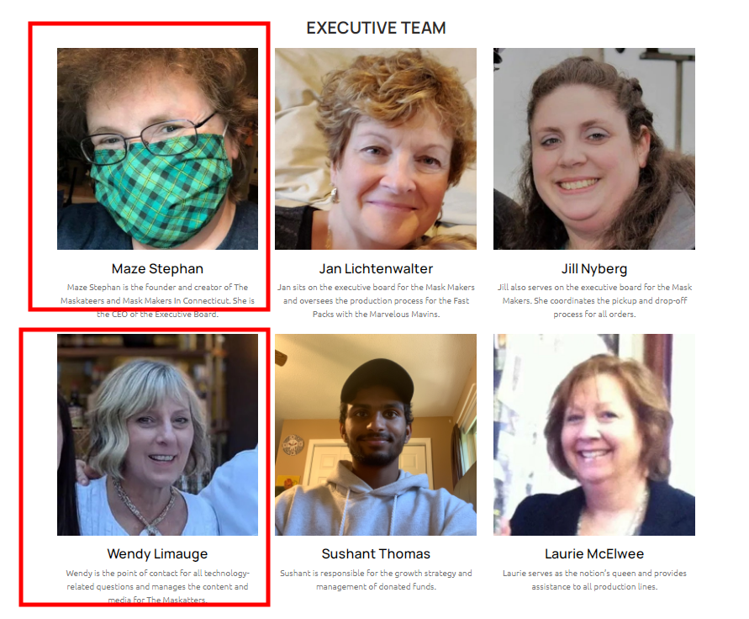

1. Remove tel funtion from there that is not phone number  
   QA: Not done  
   
2. This section isn’t dynamic  
   QA: Not done
3. Comment: this section is not needed to be dynamic if client require this we will work on it further

<http://demo-webdesignservices.com/The-Maskateers/who-we-support>  
  
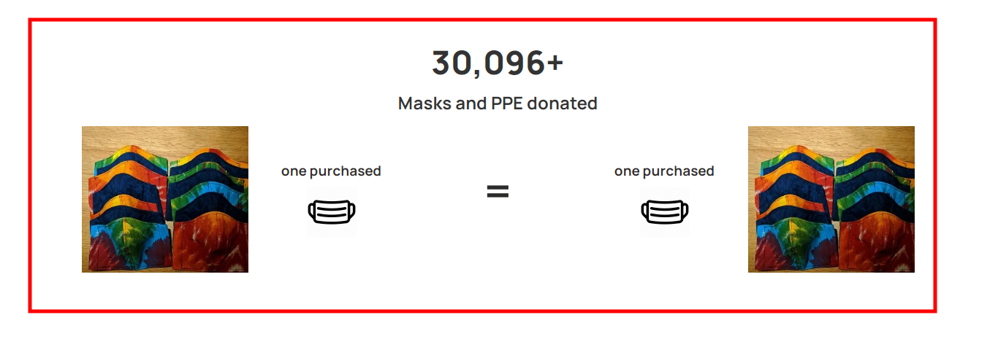

1. Set gallery layout   
   QA: Not done  
     
   <http://demo-webdesignservices.com/The-Maskateers/gallery>  
   <http://demo-designproficient.com/The-Maskateer-html/gallery.html>  
     
   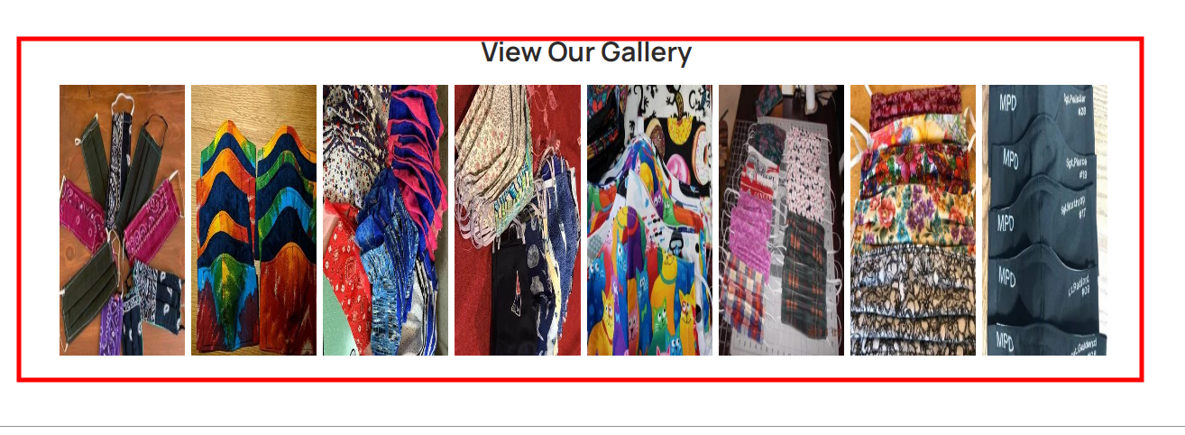
2. From where we can manage size guide section ??  
   QA: Kindly reply on this/DONE  
   http://demo-webdesignservices.com/The-Maskateers/size-guide  
     
   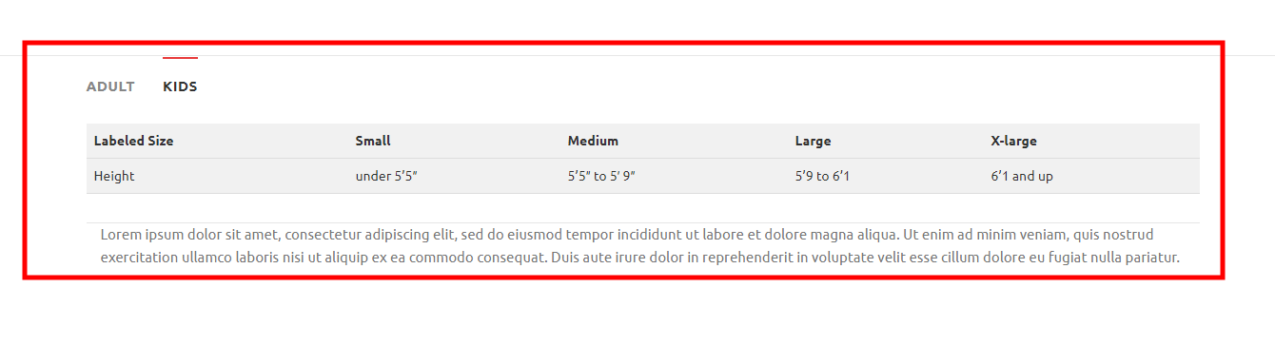
3. Add mailto function in email address  
   QA: Not done  
   <http://demo-webdesignservices.com/The-Maskateers/volunteer-with-us>

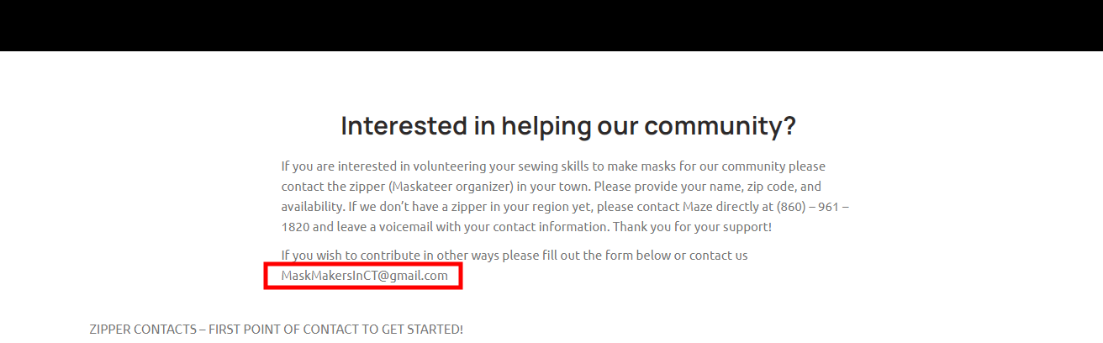

1. This content is missing in dev version  
   QA: Not done  
   <http://demo-webdesignservices.com/The-Maskateers/media-and-testimonials>

Comment: (these options are not needed)

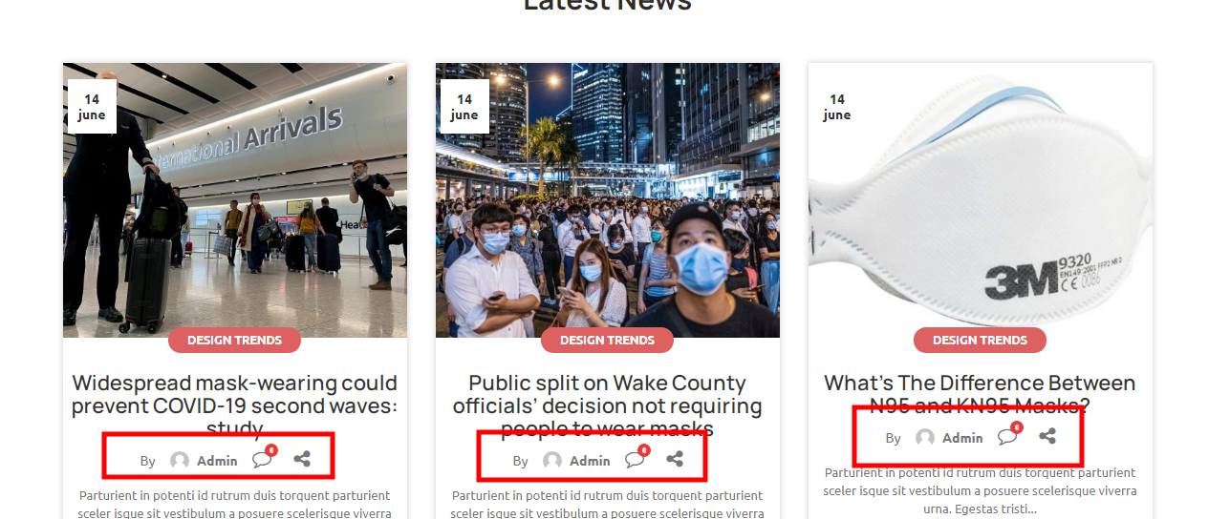

1. Set layout of news detail page  
   QA: Not done  
   <http://demo-webdesignservices.com/The-Maskateers/media-and-testimonials/1>  
     
   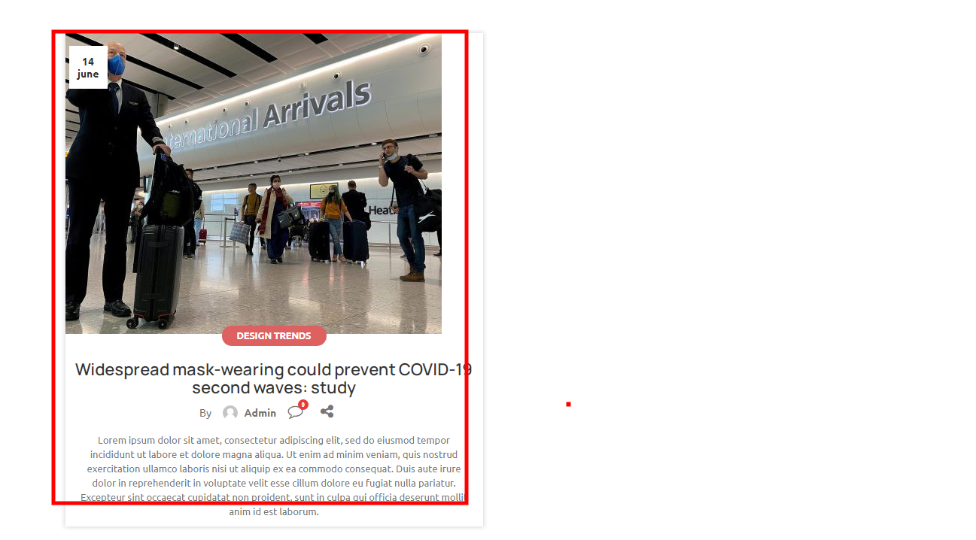
2. This form isn’t working  
   QA: Not done  
   <http://demo-webdesignservices.com/The-Maskateers/volunteer-with-us>  
     
   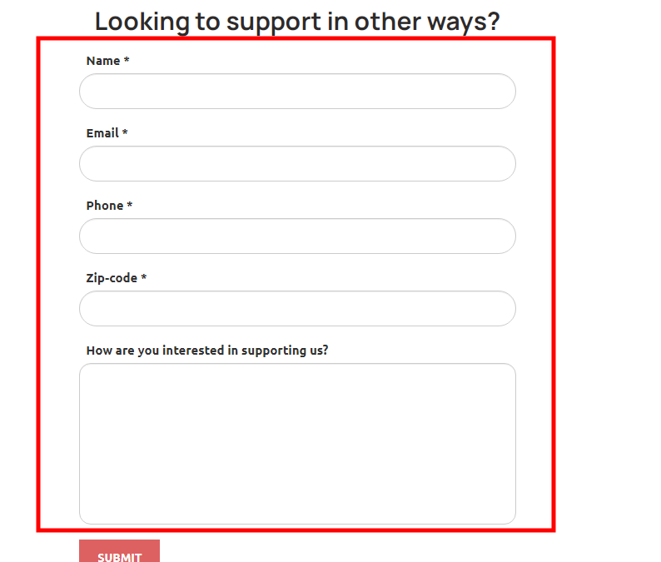
3. Price filter not working   
    product category filter missing  
     
   QA: Not done & missing compare with html version  
   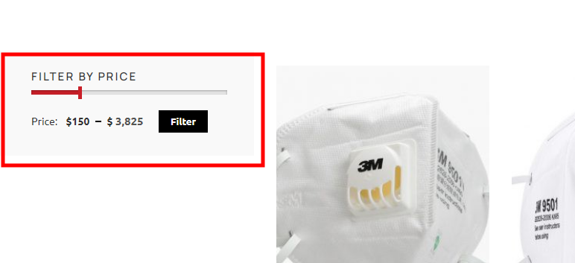  
     
   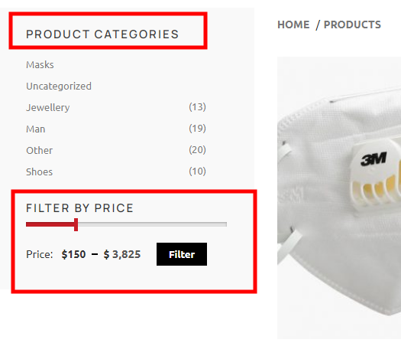
4. Not have multi images, first letter of title should be capital, quantity cannot be 0 it should be 1 minimum , I can add to cart without select size it should be restrict to first select size then able to cart. UPDATED  
    QA: Only capitalize & quantity point updated other points not done  
     
   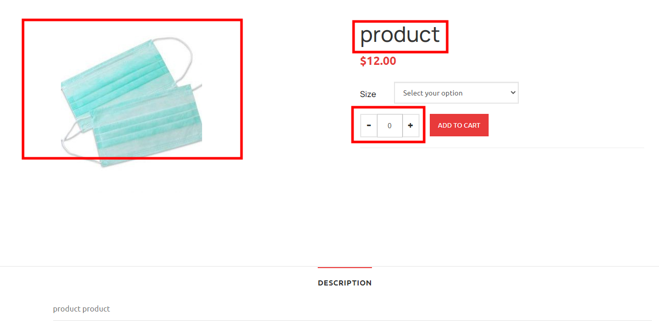
5. Below options are missing in dev version kindly add & functional them Comment: (these options are not needed)   
   QA: Noted  
     
     
   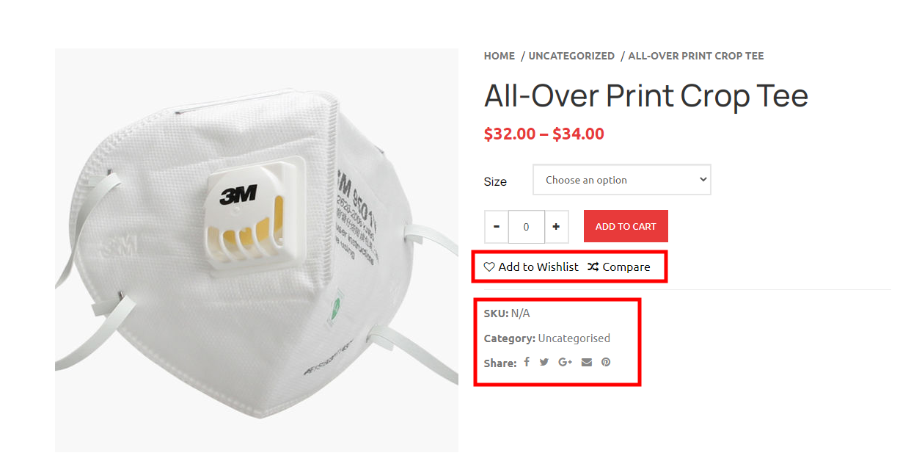  
     
   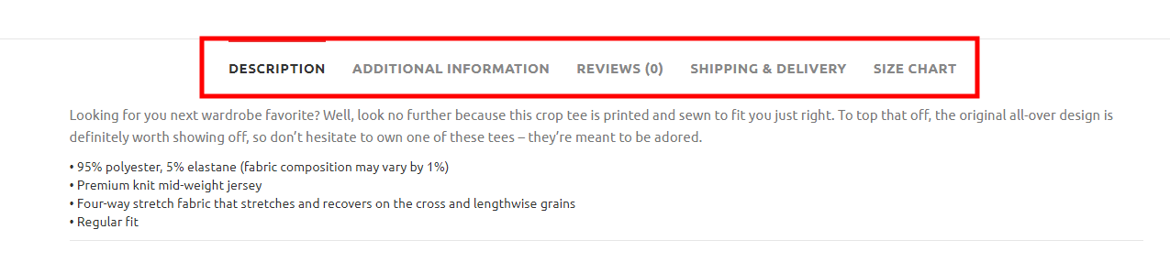
6. First letter should be capital  
    QA: Checked  
     
   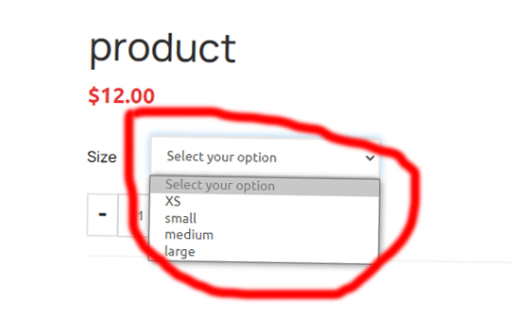
7. Capitalize first letter, product price is $12 not $1200 fix it  
    QA: Apply price format   
     
   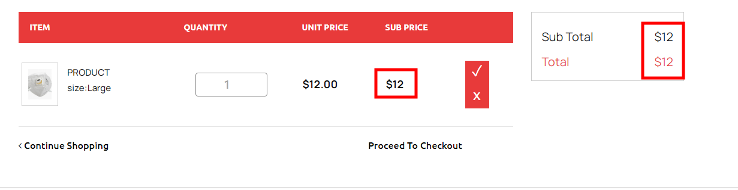  
     
   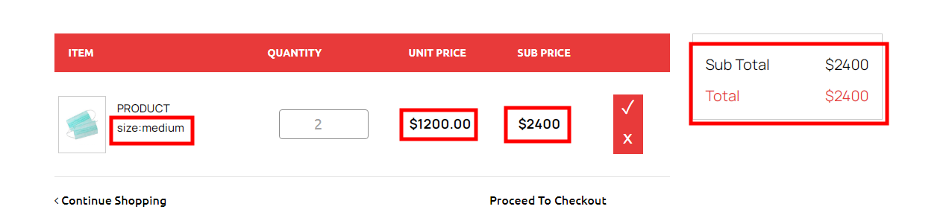
8. I am not login from any user id but login admin panel it should not show me admin as user kindly fix this. COMMENT: we are using same session for admin and user so admin can access account area.  
   QA: If admin can be like user so we having an error when we try to login from front end for example logged in admin panel & try to login it give an error kindly check & fix that  
   Comment:Kindly share the screenshotof the error so it will easy for me to recognize the error  
   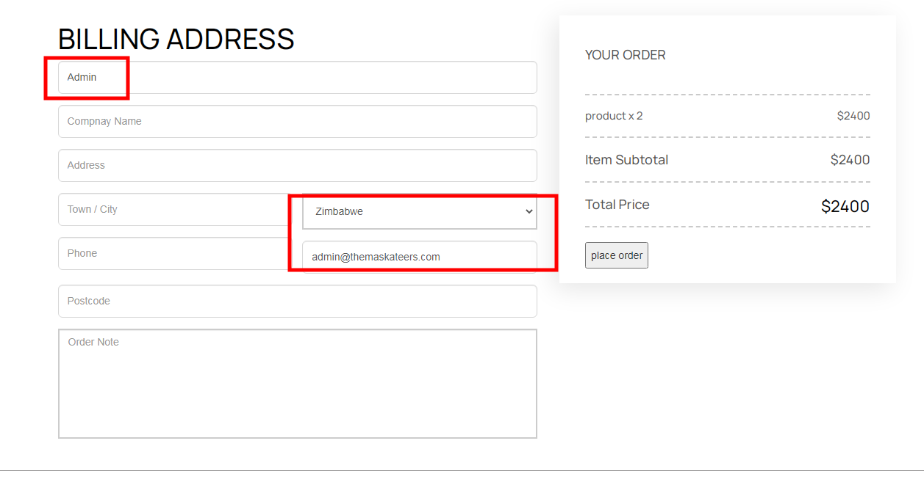
9. I can order without login any user kindly restrict to login before do any order

COMMENT:(we have given an option if user want to login so he/she can login otherwise they can placed order without login)  
 default country should be US   
 check price of product fix them as well  
 set button as other theme buttons  
QA: Apply price format on price & default country should be US  
  
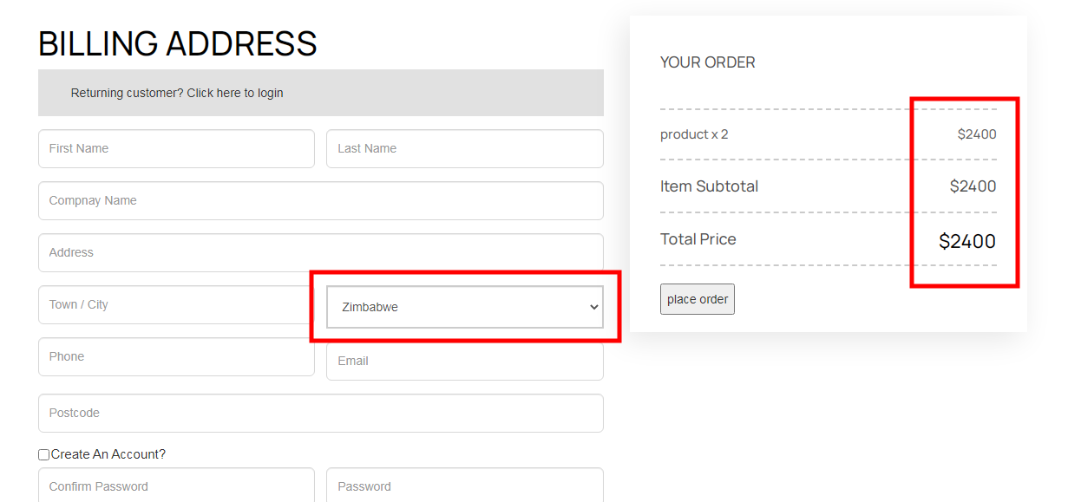

1. Set form layout as other theme layout  
    change register button name login to register  
    QA: Checked  
   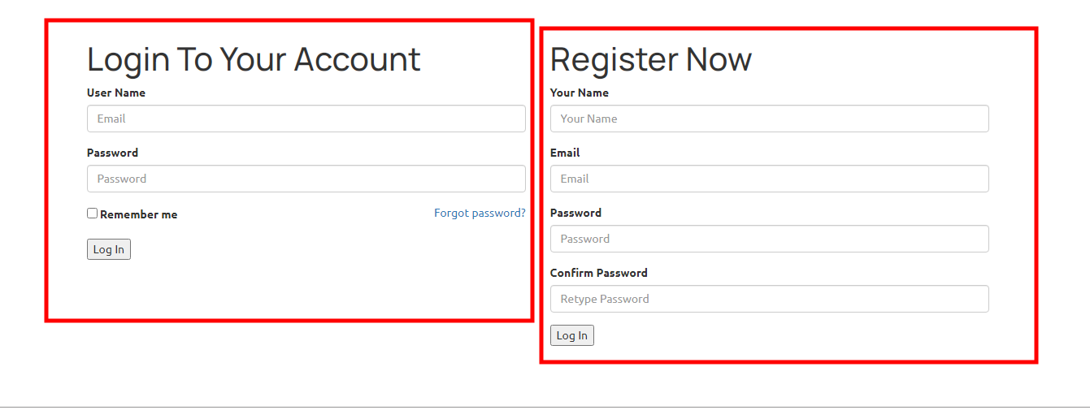
2. Make below form as other theme layout  
    QA: Checked  
   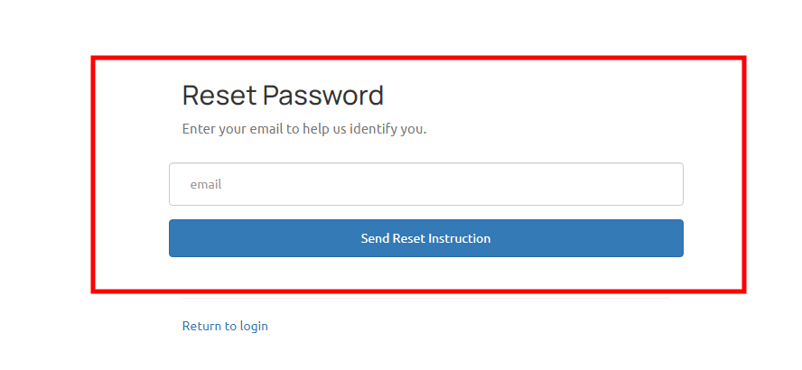
3. When we click link through email which is sent from reset password it go to error page  
   QA: Set form layout  
     
   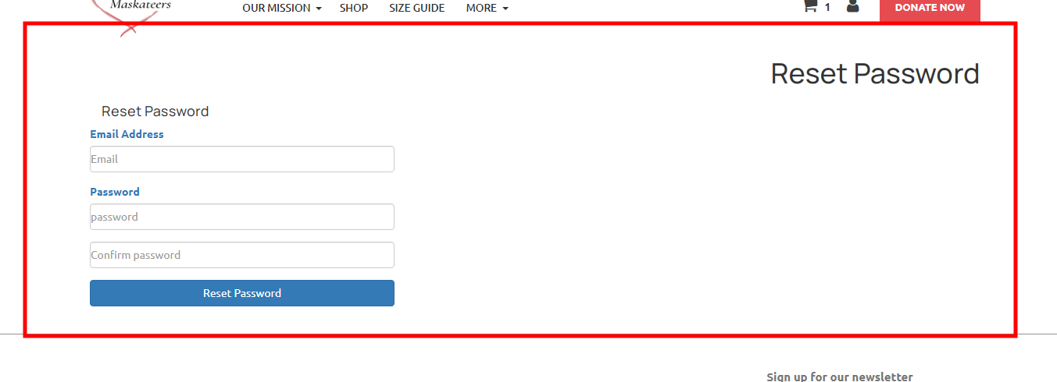  
   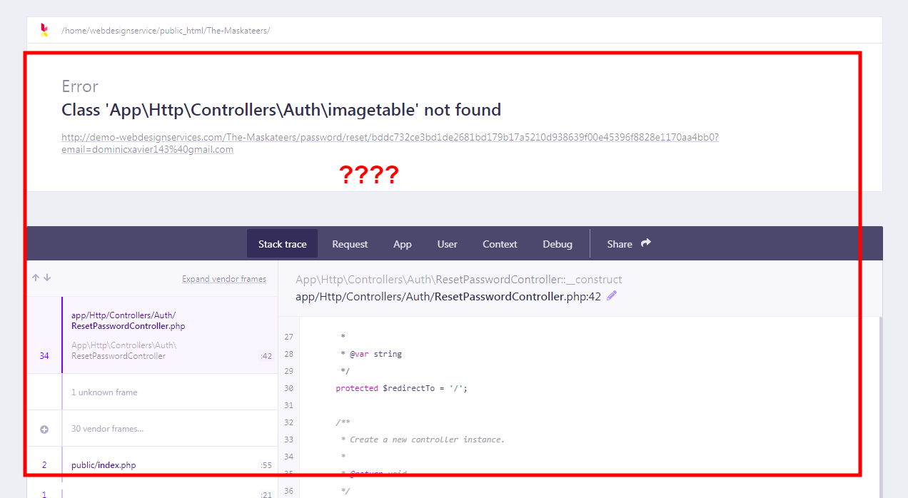
4. Order number missing,   
    price is wrong,   
    capitalize letter,  
    and size missing??  
    QA: Checked  
   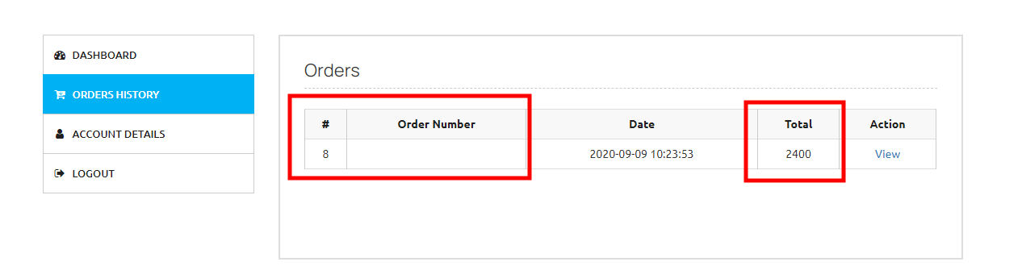  
     
   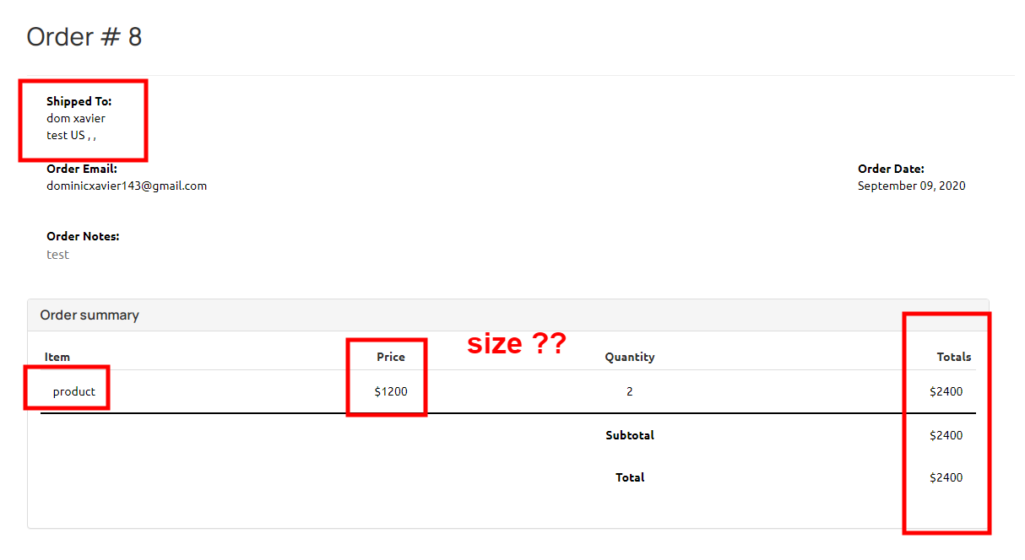
5. Title should be change in respect of every page

QA: Not done/ it is not required if it required we will work on it further

1. No order invoice receiving not in user’s email nor admin’s email.   
    QA: Not done

**Admin Panel**

1. Category management missing  
    QA: Not done

COMMENT:category management is replaced with “size of product”

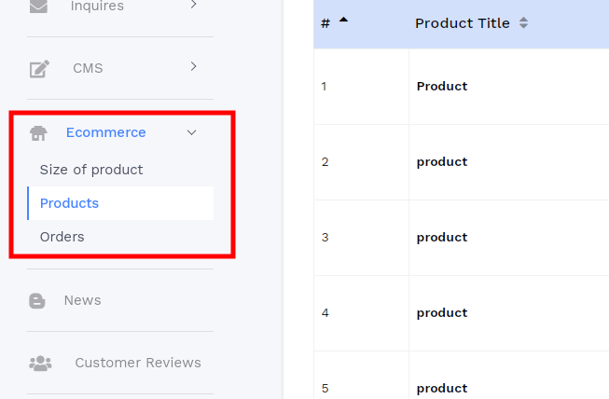

1. Size drop labeled as category which is wrong kindly fix this, add category drop down & size section should be in between not on top (category dropdown is not needed)  
   QA: Check update 1 category management is in sprint

Comment: Category, management is now replaced with “size of product” because we do not have any category given for the products   
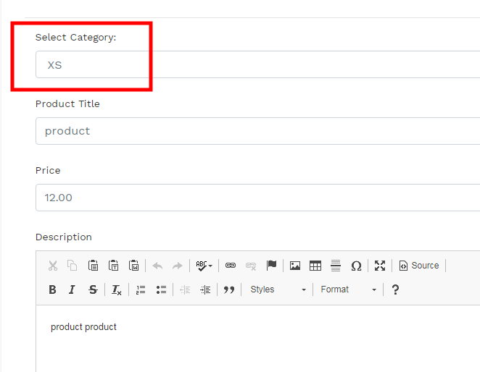

1. Capitalize titles,  
    price is wrong,  
    size missing,  
    why language heading is coming??  
    QA: Add price format, size missing, set layout remove **ZW.** from address

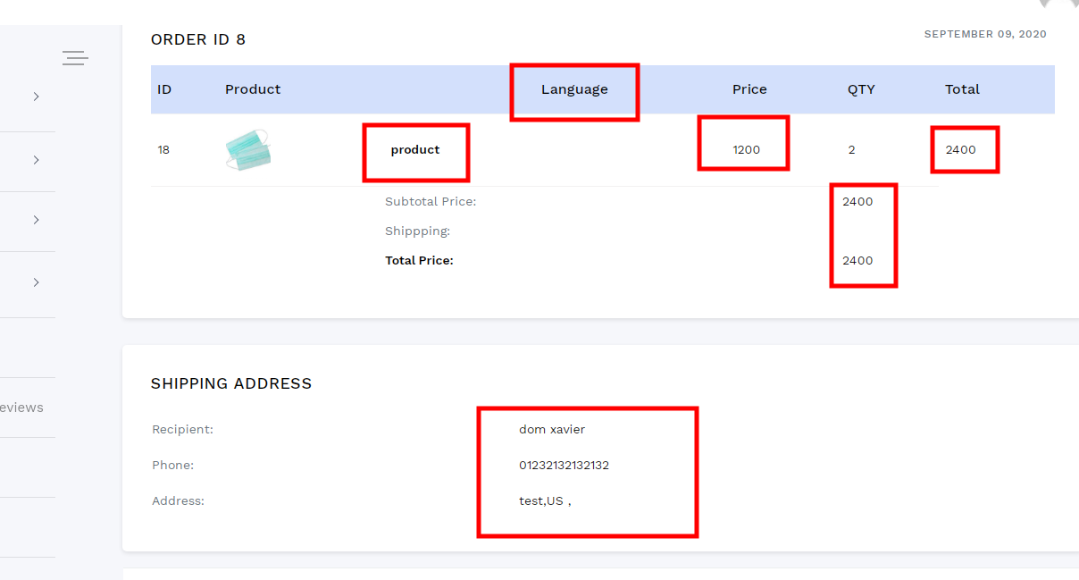

1. Volunteer management not working when we click on it going to not found error   
   QA: Volunteer management is missing

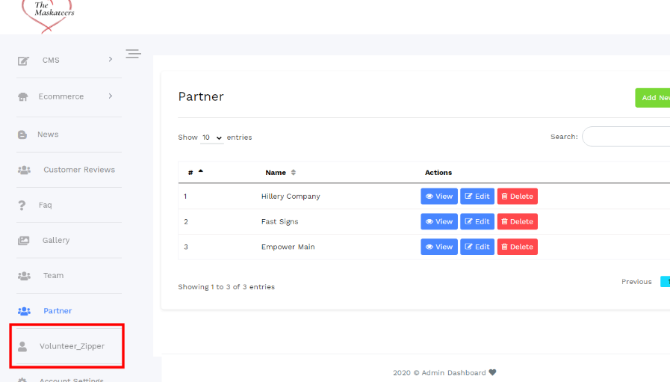

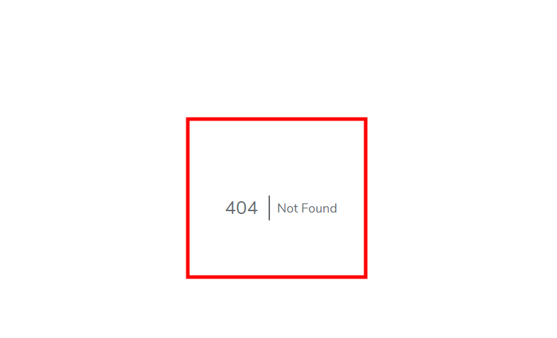

1. Use price format & add & $ with price and invoice should open to another tab  
     
   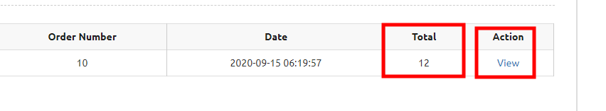
2. Address & phone no missing, order date should be on top , add price format  
     
   